Childhood Product

Name
Affiliation
Date

Childhood Product
A tape recorder is one of the childhood product which can be remembered since childhood life series. The various stages of this product since it was introduced in the market to declining is represented.
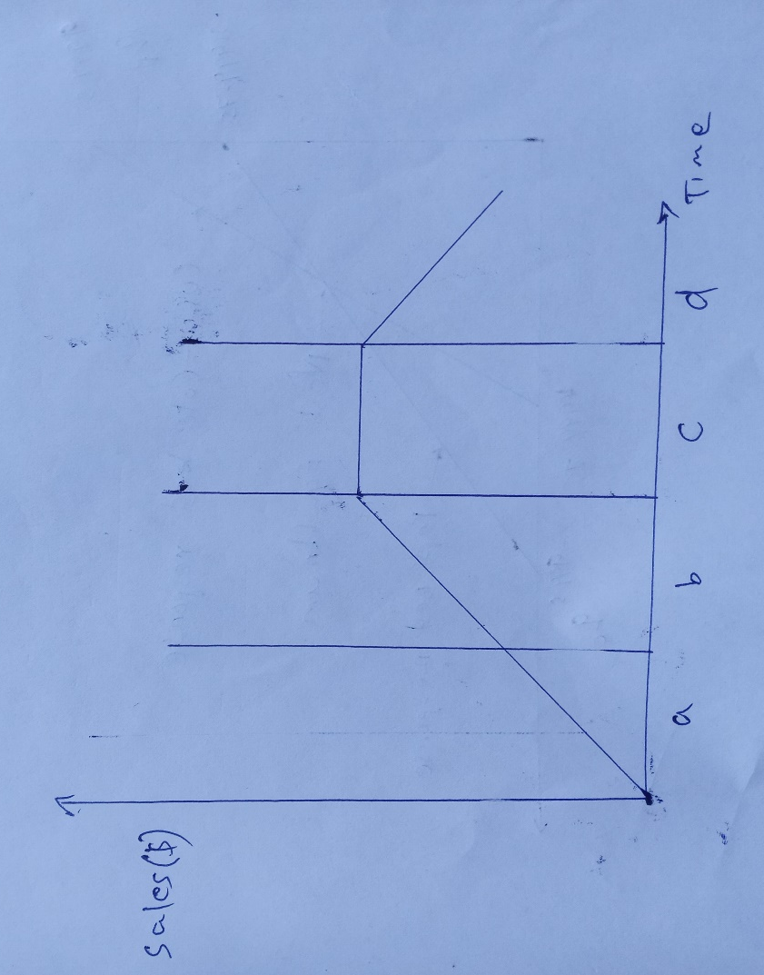
Letters a, b, c, d represents the life cycle of this product. Letter a represents the introduction of tape recorders in the market in the late 70s.letter b represents the growth in the market. The product's growth phase was between 1779 to 1982. stage C indicates the market maturity. Besides, this product's market stability was from 1983-1996. The last stage represents the decline of the product which started in 1997. A tape recorder was unique during the late 1990s since there was no competition. However, the introduction of VCD and other innovative products led to its decline. The product is utterly outdated from the beginning of the 21st century (Back, 2020).

Reference
Back, L. (2020). Tape recorder. The Auditory Culture Reader, 137-149. https://doi.org/10.4324/9781003086895-13

